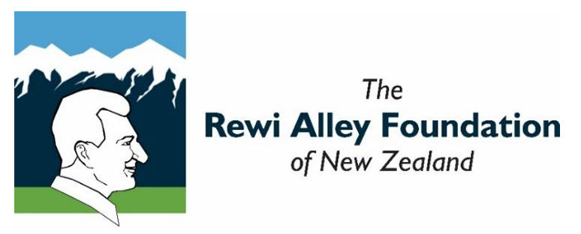
The above image is the logo of the Rewi Alley Foundation of New Zealand. This logo features Rew’s face in profile, with the Southern Alps in the background.
Timeline of Rewi Alley’s life: Copyright, Rewi Alley Foundation of NZ, 2026 ©
1897: Born on 2 December at Springfield, Canterbury, New Zealand
1916-1918: Served in France for the New Zealand Army in World War One
1920-1926: Worked on his own farm in Taranaki until economic problems forced him to walk off the land
1927: Left for China via Australia
1927: Arrived in Shanghai on 21 April. Worked as a fireman and factory inspector until 1938
1929: Helped the China International Famine Relief Commission in Inner Mongolia when the area was stricken by drought. Adopted his first son, Alan (Duan Simou)
1932: Flood relief in Hubei Province, in the cities of Wuhan and Hong Hu. Adopted his second son Mike (Li Xue). Later in 1932, made a short visit back to New Zealand
1934: Joined international political study group in Shanghai. An 'underground' radio was installed in his house to link with China's Red Army to help with resistance against the invasion of China by Imperial Japan
1937: Another visit back home to New Zealand
1938: Initiated the Gung Ho Movement (Work Together in Harmony) for Industrial Co-operatives as a survival and resistance strategy against the invasion of China by Imperial Japan
1938-1942: In 1938, Rewi became Secretary-General of the International Committee for the Promotion of Chinese Industrial Cooperatives (ICCIC, also known as Gung Ho). Throughout the next 4-5 years, he travelled widely in China to help establish these cooperatives, help with training, and support resistance work against the invading forces from Japan. Helped to establish schools for war orphans using the education philosophy of Joseph Bailie (a mixture of academic and practical hands-on learning)
1942: Spent more time on Bailie School projects. Worked with English journalist George Hogg, who became principal of the school in Shuangshipu, in Shaanxi Province
1943: Found the site and led the advance party to set up the Shandan Bailie School in Gansu Province
1945: Became principal of this school after the sudden death of George Hogg from tetanus. Remained principal until 1952 and fully developed Joseph Bailie's education philosophy to become "Hands and Mind Together - Create and Analyse". The school developed into a type of technical training institute
1953: The school was moved to Lanzhou and became the Lanzhou Oil and Technical School. Rewi was principal for a short period of time
1953: Called to Beijing to sit on the Peace Liaison Committee of the Asian and Pacific Regions, representing the New Zealand Peace Council. Rewi then moved to Beijing to live
1954 onwards: Published several books
1955: Attended the Helsinki Peace Congress as a representative of the Peace Liaison Committee
1958: Attended a meeting of the World Peace Council in Stockholm
1960: Another visit back to New Zealand
1961: Attended conference against atomic and hydrogen bombs in Japan
1962: Visited Cuba at the invitation of Che Guevara
1964: Attended the Afro-Asian Economic Conference in Pyongyang (North Korea) and also the Conference for Solidarity with the Vietnamese People Against US Imperialist Aggression, in Hanoi
1965: Participated in the Asian and African Writers' Conference in Beijing and the International Conference Against Foreign Military Bases in Jakarta (Indonesia)
1971: Extended visit to New Zealand (for around four months). Conferred an honorary Doctorate of Literature by the University of Victoria in Wellington
1972-1975: Wrote numerous poetical and prose works and books
1976: Visits to flood and earthquake-stricken areas of Henan and Liaoning
1977: 80th birthday celebrated in the Great Hall of the People in Beijing. Attended by Deng Xiaoping (Chairman of the Central Military Commission of the People's Republic of China)
1978-1982: Travel and writing in China
1982: Visited Lanzhou for the 40th anniversary celebrations of the Bailie Oil & Technical School. Revisited Shandan with old students to attend the opening ceremony of the "Exhibition of Cultural Relics Donated by Rewi Alley"
December 1982: 85th birthday celebrated with state leaders and was conferred the title of Honorary Citizen of Beijing
1984: Visited Shandan to attend the opening ceremony of the Shandan Bailie Library, built in memory of George Hogg
1985: Conferred honorary citizenship of Gansu Province. Awarded Queen's Service Order (QSO) by the New Zealand Government at a ceremony held at the New Zealand Embassy in Beijing
1986: New Zealand Prime Minister David Lange visits Rewi in Beijing
1987: Died in Beijing on 27 December, aged 90
April 1988: Ashes scattered at a formal ceremony near Shandan
Copyright, Rewi Alley Foundation of NZ, 2026 ©

